THE INDEPENDENT INSTITUTE OF EDUCATION | ROSEBANK COLLEGE, PRETORIA
iTHRIFT CLOTHES
South African pre-loved branded fashion – website and Android application

XISD6329 Work Integrated Learning 3B
Task 1 – Updated Project Plan, Site Map and Wireframes
Module | XISD6329 Work Integrated Learning 3B
Assessment | Task 1 (25% of the final module mark)
Group | Group 11
Group members | Theo Golele (ST10439863)
 | Vukosi Rikhotso (ST10439408)
Qualification | Diploma in Information Technology in Software Development
Institution | IIE Rosebank College, Pretoria
Client | iTHRIFT Clothes, Pretoria
Repository | https://github.com/ST10439408-VRIKHOTSO/iTHIFT
Date | 8 August 2026
This submission builds on the project plan, requirement analysis and system design produced for XISD5319 Work Integrated Learning 3A. Sources consulted are acknowledged in the reference list.

Table of Contents
Table of Contents 2
List of Figures 4
List of Tables 5
1. Introduction 6
1.1 Purpose of this document 6
1.2 What has changed since XISD5319 6
1.3 Where each Task 1 requirement is answered 6
2. The client's needs for the web page and the mobile application 8
2.1 The organisation 8
2.2 The problem restated for a two-channel solution 8
2.3 Needs the website must meet 8
2.4 Needs the mobile application must meet 9
2.5 Deciding what belongs on which channel 10
2.6 Feedback from the organisation on our recommendations 11
3. Updated project plan 12
3.1 Objectives for XISD6329 12
3.2 Scope 12
3.3 Deliverables allocated to each group member 12
3.4 Updated work breakdown structure 14
3.5 Updated project schedule 16
3.6 The DevOps lifecycle 17
3.6.1 Plan 17
3.6.2 Code 17
3.6.3 Build 17
3.6.4 Test 17
3.6.5 Release and deploy 17
3.6.6 Operate and monitor 17
3.6.7 Definition of done 18
3.7 Updated system architecture 18
3.8 Updated risk register 22
3.9 Updated effort and cost budget 26
3.10 Response to the XISD5319 Task 1 feedback 26
4. Site map 28
4.1 How the site map was derived 28
4.2 Website site map 28
4.3 Mobile application site map 28
4.4 Website route reference 31
4.5 Mobile navigation reference 31
4.6 Differences between the two navigation models 32
5. Wireframes 33
5.1 Conventions used 33
5.2 Website wireframes 33
5.3 Android application wireframes 33
5.4 Traceability from screen to requirement 44
6. Repository, file and folder structure 45
6.1 Repository 45
6.2 Folder structure 45
6.3 Naming conventions 45
6.4 README 46
6.5 Automated testing 46
6.6 Commit practice 46
7. Conclusion 47
8. References 47
Appendix A: Task 1 rubric self-check 48

List of Figures
Figure 1: Updated twelve-week project schedule with phase bars, owners and the four assessment milestones 19
Figure 2: The eight-phase DevOps lifecycle as applied to the iTHRIFT project, with the tool used at each phase 20
Figure 3: Updated three-tier architecture showing the website and the Android application sharing one REST API and one database 21
Figure 4: Site map of the iTHRIFT website, organised by access tier 29
Figure 5: Site map of the iTHRIFT Android application, with the five bottom-navigation tabs as the top-level nodes 30
Figure 6: Website: catalogue and landing screen (#/shop) 34
Figure 7: Website: product detail with gallery and reviews (#/product/:id) 35
Figure 8: Website: cart with order summary (#/cart) 36
Figure 9: Website: checkout and order confirmation (#/checkout, #/order-confirmation/:id) 37
Figure 10: Website: sign in and registration (#/login, #/register) 38
Figure 11: Website: order history and order tracking (#/orders, #/orders/:id) 39
Figure 12: Website: staff and administrator console (#/admin) 40
Figure 13: Android application: Shop, Search and Product Detail 41
Figure 14: Android application: Cart, Checkout and Order Confirmation 42
Figure 15: Android application: Orders, Order Detail and Account with settings 43

List of Tables
Table 1: Task 1 requirements mapped to the sections of this document 6
Table 2: Client needs served by the website 8
Table 3: Client needs served by the Android application 9
Table 4: Allocation of functions to the website and the Android application 10
Table 5: Client feedback on the recommendations made (to be completed at the review meeting) 11
Table 6: Project scope for XISD6329 12
Table 7: Deliverables allocated to each group member 13
Table 8: Updated work breakdown structure 14
Table 9: Definition of done for every work item 18
Table 10: Updated risk register 22
Table 11: Updated effort and cost budget 26
Table 12: Carry-over of the XISD5319 Task 1 feedback into this plan 27
Table 13: Website routes, access level and purpose 31
Table 14: Android application screens, host fragment and how each is reached 31
Table 15: Traceability of use cases to wireframed screens 44
Table 16: Self-check against the Task 1 marking rubric 48

1. Introduction

1.1 Purpose of this document
In XISD5319 this group planned, analysed and designed an e-commerce platform for iTHRIFT Clothes, a Pretoria business that buys and resells pre-owned branded clothing, and delivered a working web prototype. XISD6329 carries that work forward. The system must now be delivered as two connected products – a fully working website and a native Android application – built and released through a DevOps pipeline rather than by hand.
This document is the Task 1 submission. It restates what the client needs from each of the two channels, presents the project plan updated for this semester with the DevOps lifecycle folded into it, and sets out the site map and wireframes that the Task 2 build will be measured against. It is accompanied by the project repository on GitHub, which already holds the site markup, assets, README and automated test workflows described in Section 6.

1.2 What has changed since XISD5319
Four things changed, and each of them has consequences that run through the rest of this plan.
- A second client surface. The solution is no longer one website. A native Android application, written in Kotlin, now sits alongside it and consumes the same API. Section 2 separates what the client needs from each surface, because they are not the same thing.
- A shared back end. In XISD5319 the design assumed PHP pages rendering HTML directly from MySQL. To serve two clients from one code base, the application tier is now a JSON REST API. The three-tier structure and the Third Normal Form schema are unchanged; only the contract between the tiers is.
- DevOps replaces hand-off. Testing and deployment were phases seven and eight of the old schedule. They are now continuous: every push to the repository builds and tests both clients before the change is accepted. Section 3.6 sets this out.
- A shorter schedule. The XISD5319 plan ran to fourteen weeks. This module runs to twelve, with Task 1 due in week 5 and Task 2 in week 10. The Gantt chart in Section 3.5 has been rebuilt against the module pacer rather than adjusted at the edges.

1.3 Where each Task 1 requirement is answered
Table 1 maps every item in the Task 1 brief and marking rubric to the section that answers it, so the submission can be checked against the rubric without hunting.
Table 1: Task 1 requirements mapped to the sections of this document
Requirement (brief and rubric) | Where it is answered
Cover page, table of contents, list of figures | Front matter, pages i to iv
Description of the client's needs for the web page and mobile app | Section 2
Update project plan | Section 3
DevOps lifecycle included in the plan | Section 3.6, Figure 2
Deliverables allocated to each member of the group | Section 3.3, Table 7
Site map | Section 4, Figures 4 and 5
Wireframes for the web pages and the app design | Section 5, Figures 6 to 15
File and folder structure in the repository | Section 6.2 and 6.3
HTML page code across all pages | Section 6.2; source in the repository
GitHub, README and automated testing | Section 6.4 and 6.5
Web page content across all pages | Section 5.2 and Section 6.2

2. The client's needs for the web page and the mobile application

2.1 The organisation
iTHRIFT Clothes sources pre-owned branded clothing from suppliers, individuals and thrift channels across South Africa. Every item is inspected, photographed and graded Excellent, Very Good, Good or Fair before it goes on sale. The business trades from physical stores in Pretoria and, for everything else, through WhatsApp and Instagram. There is no single system behind any of it.
That informality is the problem. Stock lives in one person's head, prices are quoted in direct messages, orders are tracked in a chat thread, and a customer outside Pretoria has no reliable way to see what is available or buy it. The business is not short of demand; it is short of a channel that can carry the demand it already has.

2.2 The problem restated for a two-channel solution
The XISD5319 requirement analysis captured fourteen use cases, UC1 to UC14, covering registration and login, browsing, searching and filtering, cart and checkout, payment, order tracking, listing management, order processing, user administration, reporting and reviews. Those requirements have not changed. What has changed is that they must now be satisfied across two clients with genuinely different jobs.
The distinction matters commercially. Staff work at a desk with a keyboard, a large screen and a folder of product photographs to upload; that is a website task. Customers, in South Africa, shop on a phone. Treating the mobile application as a shrunken copy of the website would give staff a console they cannot use properly and customers a store that feels like a website in a frame. The two are therefore specified separately below.

2.3 Needs the website must meet
The website is the full-service channel. It is the only surface where the business itself operates, and it is the surface a customer reaches from a shared link, a search result or a desktop at work.
Table 2: Client needs served by the website
Client need | How the website meets it | Use case
A branded storefront that shows stock properly | Catalogue grid with large photographs, brand, size, condition grade and price on every card, and a detail page with a full image gallery | UC3
Customers must find a specific piece quickly | Keyword search plus filters on category, brand, condition, price range and stock, with sorting by price and by newest | UC4
Customer accounts and order history | Registration, sign-in, profile and delivery address management, and a full order history with downloadable detail | UC1, UC2, UC14
Buying without a phone call | Cart, checkout with a delivery address, PayFast card payment or EFT, and an order confirmation with a reference number | UC5, UC6, UC7
Customers can see where their order is | Order status tracker moving through Placed, Processing, Shipped and Delivered, with the courier reference shown once captured | UC8
Staff must manage listings without a developer | Admin console with add, edit, mark out of stock and delete for every listing, including photograph upload and condition grading | UC9
Staff must process orders as they arrive | Order queue filtered by status, with a status update control and a field for the courier reference | UC10
Management need to see how the business is doing | Dashboard with revenue, order counts by status, and revenue broken down by brand and by category, plus a low-stock report | UC12
Administrators must control who has access | User administration to view, suspend, reactivate or delete customer accounts, visible to the administrator role only | UC11
Buyers trust other buyers | Star rating and written reviews on the product detail page, restricted to signed-in customers | UC13

2.4 Needs the mobile application must meet
The Android application is the customer channel. It carries no administrative function at all. Its job is to make browsing and buying fast on a phone, and to be the place a returning customer checks an order without opening a browser.
Table 3: Client needs served by the Android application
Client need | How the application meets it | Use case
Reach customers where they already are | An installed Android application with an icon on the home screen, rather than a link the customer has to remember | UC3
Browsing must feel quick on a phone | Two-column product grid in a RecyclerView, category chips across the top, and images cached so a scroll back up does not re-download | UC3
Search that suits a small screen | A dedicated Search tab with the filter panel on its own screen rather than a dropdown squeezed into a header | UC4
Sign in without typing a password on a phone keyboard | Email and password sign-in with the password encrypted in transit and at rest, plus single sign-on so a customer can use an existing account | UC1, UC2
Buy in as few taps as possible | Add to cart from the product detail screen, a persistent cart badge on the bottom navigation, and a three-step checkout | UC5, UC6, UC7
Check an order without opening a browser | Orders tab with a status badge on every order and a vertical status tracker on the order detail screen | UC8, UC14
Control over the application itself | Settings screen covering the API endpoint, notification preference, theme and local cache, and a clear sign-out | UC2
The application must not break on a bad connection | Every network call returns a typed result, and each screen has a defined loading, empty and error state rather than a crash | Non-functional

2.5 Deciding what belongs on which channel
Table 4 records the decision for every function, and the reason. This is the table the group will be held to during Task 2, and it is deliberately explicit about what the application will not do.
Table 4: Allocation of functions to the website and the Android application
Function | Website | Android app | Reason for the decision
Browse and filter the catalogue | Yes | Yes | Core to both; the primary reason a customer opens either
Product detail and reviews | Yes | Yes | Same content, laid out for the available width
Register, sign in, manage profile | Yes | Yes | A customer must be able to start on one and continue on the other
Cart, checkout and payment | Yes | Yes | Both are selling channels
Order history and tracking | Yes | Yes | The most common reason a customer returns
Manage listings | Yes | No | Staff upload photographs from a computer and work from a large screen
Process orders and capture courier references | Yes | No | Done at a desk against a printed picking list
Reports and dashboard | Yes | No | Tables and charts are unreadable on a phone
User administration | Yes | No | Administrator-only and low frequency; no case for a mobile version
Push notification on status change | No | Yes | Only the installed application can reach the customer once it is closed

2.6 Feedback from the organisation on our recommendations
The module requires the group to record the documented feedback the organisation gives on the recommendations made to it. Table 5 is the instrument used to capture that feedback at the review meeting. Each row records the recommendation put to the client, the response received, and the action the group has taken as a result.
To be completed: the response and action columns must be filled in from the notes taken at the client review meeting before this document is submitted. Recommendations 1 to 5 are the ones actually put to iTHRIFT Clothes; do not change them.
Table 5: Client feedback on the recommendations made (to be completed at the review meeting)
# | Recommendation put to iTHRIFT Clothes | Client response | Action taken
R1 | Keep all administrative functions on the website and make the Android application customer-only
R2 | Grade every listing on a four-point condition scale and show the grade on the card, not only on the detail page
R3 | Offer PayFast, EFT and cash on delivery rather than card only, to suit customers without a card
R4 | Publish the application to the Google Play Store rather than distributing an APK file directly
R5 | Retire the WhatsApp and Instagram order threads once the platform is live, and use those channels for marketing only

3. Updated project plan

3.1 Objectives for XISD6329
The project objective for this semester is to deliver, test and release a working two-channel solution for iTHRIFT Clothes within twelve weeks. Concretely, the group commits to the following.
- Deliver a fully working website covering the customer storefront and the staff and administrator console.
- Deliver a native Android application that installs and runs on a physical handset, not only on an emulator.
- Serve both clients from one REST API and one Third Normal Form database, so that a change to a business rule is made once.
- Run the full DevOps lifecycle, with an Azure Boards Kanban board for planning and GitHub Actions for automated build, test and release.
- Write unit and integration tests that run automatically on every push, and treat a failing pipeline as a blocked change.
- Prepare the application for publication on the Google Play Store, including a signed release build and store assets.
- Update every document produced in XISD5319 so that it still describes the system that has actually been built.

3.2 Scope
Table 6: Project scope for XISD6329
In scope | Out of scope for this phase
Customer storefront on web and Android | A peer-to-peer marketplace where customers list their own items
Staff and administrator console on the web | An iOS application
Shared REST API and relational database | Multi-currency pricing and international delivery
Authentication, roles and single sign-on | A loyalty or points scheme
Cart, checkout, payment capture and order lifecycle | Live integration with a courier tracking API
Reviews and ratings | In-app live chat with the shop
Reporting for management | Automated accounting or stock-reorder integration
Automated build, test and release pipeline | Production hosting on a paid commercial plan
Help system and user documentation | Formal penetration testing by a third party

3.3 Deliverables allocated to each group member
The group has two members. Roles carry over from XISD5319, with the split adjusted so that each member owns one client surface end to end while the shared API and database remain jointly owned. Ownership means the named member is accountable for the deliverable being finished and working; it does not prevent the other member contributing, and per the module guidelines both members may work across all sections.
Table 7: Deliverables allocated to each group member
Deliverable | Owner | Supporting member | Due
Updated project plan, scope and risk register | Theo Golele | Vukosi Rikhotso | Week 3
Site maps for the website and the application | Vukosi Rikhotso | Theo Golele | Week 3
Website wireframes | Theo Golele | Vukosi Rikhotso | Week 4
Android application wireframes | Theo Golele | Vukosi Rikhotso | Week 4
GitHub repository, branch policy and README | Vukosi Rikhotso | Theo Golele | Week 2
Azure DevOps project and Kanban board | Vukosi Rikhotso | Theo Golele | Week 3
Task 1 document, compiled and submitted | Theo Golele | Vukosi Rikhotso | Week 5
Website markup, styling and client-side logic | Theo Golele | Vukosi Rikhotso | Week 7
REST API endpoints and business rules | Vukosi Rikhotso | Theo Golele | Week 8
Database schema, seed data and migrations | Vukosi Rikhotso | - | Week 6
Android UI: Shop, Search and Product Detail | Theo Golele | Vukosi Rikhotso | Week 8
Android UI: Cart, Checkout, Orders and Account | Vukosi Rikhotso | Theo Golele | Week 9
Authentication, roles and single sign-on | Vukosi Rikhotso | Theo Golele | Week 8
Unit tests and GitHub Actions workflows | Vukosi Rikhotso | Theo Golele | Week 10
Help system and user documentation | Theo Golele | - | Week 11
Demonstration video and release notes | Theo Golele | Vukosi Rikhotso | Week 11
Signed release build and Play Store assets | Vukosi Rikhotso | Theo Golele | Week 11
Final project report and presentation | Both members | - | Week 12
Accountability is enforced through the Kanban board. Every work item carries an assignee, and an item that has not moved for a week is raised at the weekly collaboration session. If a member repeatedly fails to deliver an allocated item, the module manual requires the other member to report it to the lecturer for intervention and to record it in the peer evaluation; the group has agreed to follow that process rather than silently absorbing the work.

3.4 Updated work breakdown structure
The work breakdown structure below replaces the eight-phase structure used in XISD5319. It has eleven level-one phases, reflecting the split of the client tier into two products and the promotion of testing and release from end-of-project phases to continuous activities. Each work package carries a duration, a predecessor, the responsible member and the resulting deliverable.
Table 8: Updated work breakdown structure
WBS | Work package | Dur. | Pred. | Owner
P1 | Project initiation and re-planning | 2 wk | - | Both
1.1 | Review XISD5319 feedback and confirm what carries over | 2 d | - | Both
1.2 | Confirm the two-channel scope with the client | 1 d | 1.1 | Theo
1.3 | Rebuild the schedule against the module pacer | 2 d | 1.2 | Theo
1.4 | Update the risk register and the effort budget | 2 d | 1.3 | Both
P2 | Design update: site map and wireframes | 4 wk | P1 | Both
2.1 | Derive the site map from the implemented routes | 3 d | 1.2 | Vukosi
2.2 | Draw the website wireframes | 4 d | 2.1 | Theo
2.3 | Draw the Android application wireframes | 4 d | 2.1 | Theo
2.4 | Review the wireframes against the fourteen use cases | 2 d | 2.2, 2.3 | Both
2.5 | Compile and submit the Task 1 document | 2 d | 2.4 | Theo
P3 | DevOps set-up | 2 wk | P1 | Vukosi
3.1 | Create the GitHub repository and branch policy | 1 d | 1.1 | Vukosi
3.2 | Create the Azure DevOps project and Kanban board | 1 d | 3.1 | Vukosi
3.3 | Load the backlog and link work items to branches | 2 d | 3.2 | Both
3.4 | Write the first build and test workflows | 3 d | 3.1 | Vukosi
P4 | Website update and refactor | 5 wk | P2 | Theo
4.1 | Rework the storefront against the wireframes | 5 d | 2.2 | Theo
4.2 | Catalogue, search, filter and product detail pages | 5 d | 4.1 | Theo
4.3 | Cart, checkout and order tracking pages | 4 d | 4.2 | Theo
4.4 | Staff and administrator console | 5 d | 4.3 | Theo
4.5 | Accessibility and responsive behaviour pass | 3 d | 4.4 | Theo
P5 | REST API and database | 5 wk | P2 | Vukosi
5.1 | Confirm the API contract used by both clients | 2 d | 2.1 | Both
5.2 | Schema, seed data and migration scripts | 4 d | 5.1 | Vukosi
5.3 | Authentication, roles and single sign-on | 5 d | 5.2 | Vukosi
5.4 | Catalogue, cart and order endpoints | 6 d | 5.2 | Vukosi
5.5 | Reporting endpoints for the dashboard | 3 d | 5.4 | Vukosi
P6 | Android application development | 6 wk | P5 | Both
6.1 | Project skeleton, navigation shell and theme | 3 d | 5.1 | Theo
6.2 | API client, session handling and typed results | 4 d | 6.1 | Vukosi
6.3 | Shop, Search and Product Detail screens | 6 d | 6.2 | Theo
6.4 | Cart, Checkout and Order Confirmation screens | 6 d | 6.3 | Vukosi
6.5 | Orders, Order Detail and Account screens | 5 d | 6.4 | Vukosi
6.6 | Install and test on a physical handset | 3 d | 6.5 | Both
P7 | Automated testing | 5 wk | P3 | Vukosi
7.1 | Unit tests for the API business rules | 4 d | 5.4 | Vukosi
7.2 | End-to-end smoke test across the API surface | 3 d | 7.1 | Vukosi
7.3 | Instrumented and unit tests for the application | 4 d | 6.5 | Both
7.4 | Wire the test suites into GitHub Actions | 2 d | 7.2, 7.3 | Vukosi
P8 | Help system and user documentation | 4 wk | P4 | Theo
P9 | Release preparation | 3 wk | P6, P7 | Both
9.1 | Signed release build and release notes | 3 d | 7.4 | Vukosi
9.2 | Play Store listing, screenshots and assets | 3 d | 9.1 | Vukosi
9.3 | Demonstration video with voice-over | 3 d | 6.6 | Theo
P10 | Final project report | 2 wk | P9 | Both
P11 | Presentation and hand-over | 1 wk | P10 | Both

3.5 Updated project schedule
Figure 1 shows the twelve-week schedule. The critical path runs P1 to P2 to P5 to P6 to P7 to P9 to P10: the API must exist before the Android client can be built against it, the client must exist before it can be tested, and the tests must pass before a release can be cut. Website work (P4) is deliberately off the critical path, so a delay there costs presentation quality rather than the submission itself.
Weeks 5 to 7 carry three concurrent phases. This is possible only because the API contract is agreed in work package 5.1 before any client code is written; both developers then build against the same agreed contract instead of waiting for each other. The main scheduling risk is week 8, where the Android screens, the reporting endpoints and the first test suites all land in the same fortnight. The schedule is drawn in Figure 1, which appears with Figures 2 and 3 at the end of this section.

3.6 The DevOps lifecycle
DevOps is the practice of joining development and operations into one continuous loop so that software can be built, tested and released repeatedly and reliably rather than in one large hand-over at the end (Microsoft, 2025). The module requires the full lifecycle to be used to manage this application, and Figure 2 shows how the eight phases map onto the tools this group is using.

3.6.1 Plan
Planning is done on an Azure Boards Kanban board with the columns To Do, In Progress, In Review, Testing and Done. Every work package in Table 8 becomes an epic and is broken into work items small enough to finish in a day or two. Each item names an assignee, a rubric criterion it serves, and an acceptance test. Work items are linked to the branch and the pull request that implement them, so the board and the repository never drift apart.

3.6.2 Code
All source lives in one GitHub repository holding the website, the API and the Android application, so that a change to a shared contract is made in a single commit. Work happens on short-lived feature branches named for the work item; the main branch is protected and only changes through a pull request that the other member has reviewed. Commit messages state what changed and why, and reference the work item number.

3.6.3 Build
Two GitHub Actions workflows run on every push and pull request. The first installs the API dependencies with a clean, lock-file-driven install and starts the server. The second runs the Gradle wrapper to assemble a debug build of the Android application. The purpose is to prove the code builds on a clean machine, not only on the machine that wrote it, which is the failure this module explicitly warns against.

3.6.4 Test
Testing runs in the same workflow as the build and gates it. On the server side an end-to-end smoke test exercises the API as a real client would – registration, sign-in, catalogue filtering, cart operations, checkout, stock decrement, order status transitions and the role checks that keep customers out of the administrator routes. On the application side, unit tests cover the pure logic (cart totals, price formatting, validation) and instrumented tests cover the screens. A red pipeline blocks the merge.

3.6.5 Release and deploy
A build that passes integration produces a versioned artefact: a signed Android package attached to the workflow run, together with release notes listing what changed since the previous build. Deployment for this project means installing that package on a physical handset for the demonstration and, at the end of the module, uploading it to the Google Play Console. The API is deployed to a host both clients can reach so that the demonstration does not depend on one laptop being switched on.

3.6.6 Operate and monitor
Operating the system means keeping a demonstration environment that works: a seeded database, known demo accounts for the customer, staff and administrator roles, and the help system reachable from the application. Monitoring is deliberately modest at this scale – structured server-side logging for every request and error, and Android logging at the boundaries of each network call. Anything found in operation becomes a new work item on the board, which closes the loop back to Plan.

3.6.7 Definition of done
To keep the lifecycle honest, the group has agreed a single definition of done. A work item is not done because the code was written; it is done when every line of Table 9 is true.
Table 9: Definition of done for every work item
# | Condition
1 | The change is on a feature branch and merged through a reviewed pull request.
2 | Both build workflows pass on the pull request, with no warnings that were introduced by the change.
3 | Tests cover the new behaviour, and the whole suite passes.
4 | Any user-facing text, help content or README section affected by the change has been updated.
5 | The change has been exercised by hand on a physical handset if it touches the application, or in a browser if it touches the website.
6 | The work item is moved to Done on the board with a note on anything left outstanding.

3.7 Updated system architecture
The three-tier architecture specified in the XISD5319 system design is retained. The change is that the presentation tier now has two occupants, and the contract between the presentation and application tiers is JSON over HTTPS rather than server-rendered HTML.
The security reasoning behind the original design is unchanged and, if anything, more important now. The database is reachable only from the application tier over the local interface; every query is parameterised; and role checks are performed on the server for every request. Hiding a menu item in either client is a convenience, never a control – a point returned to in Section 4. The three figures for this section follow on the next three pages: the project schedule, the DevOps lifecycle, and the updated architecture.
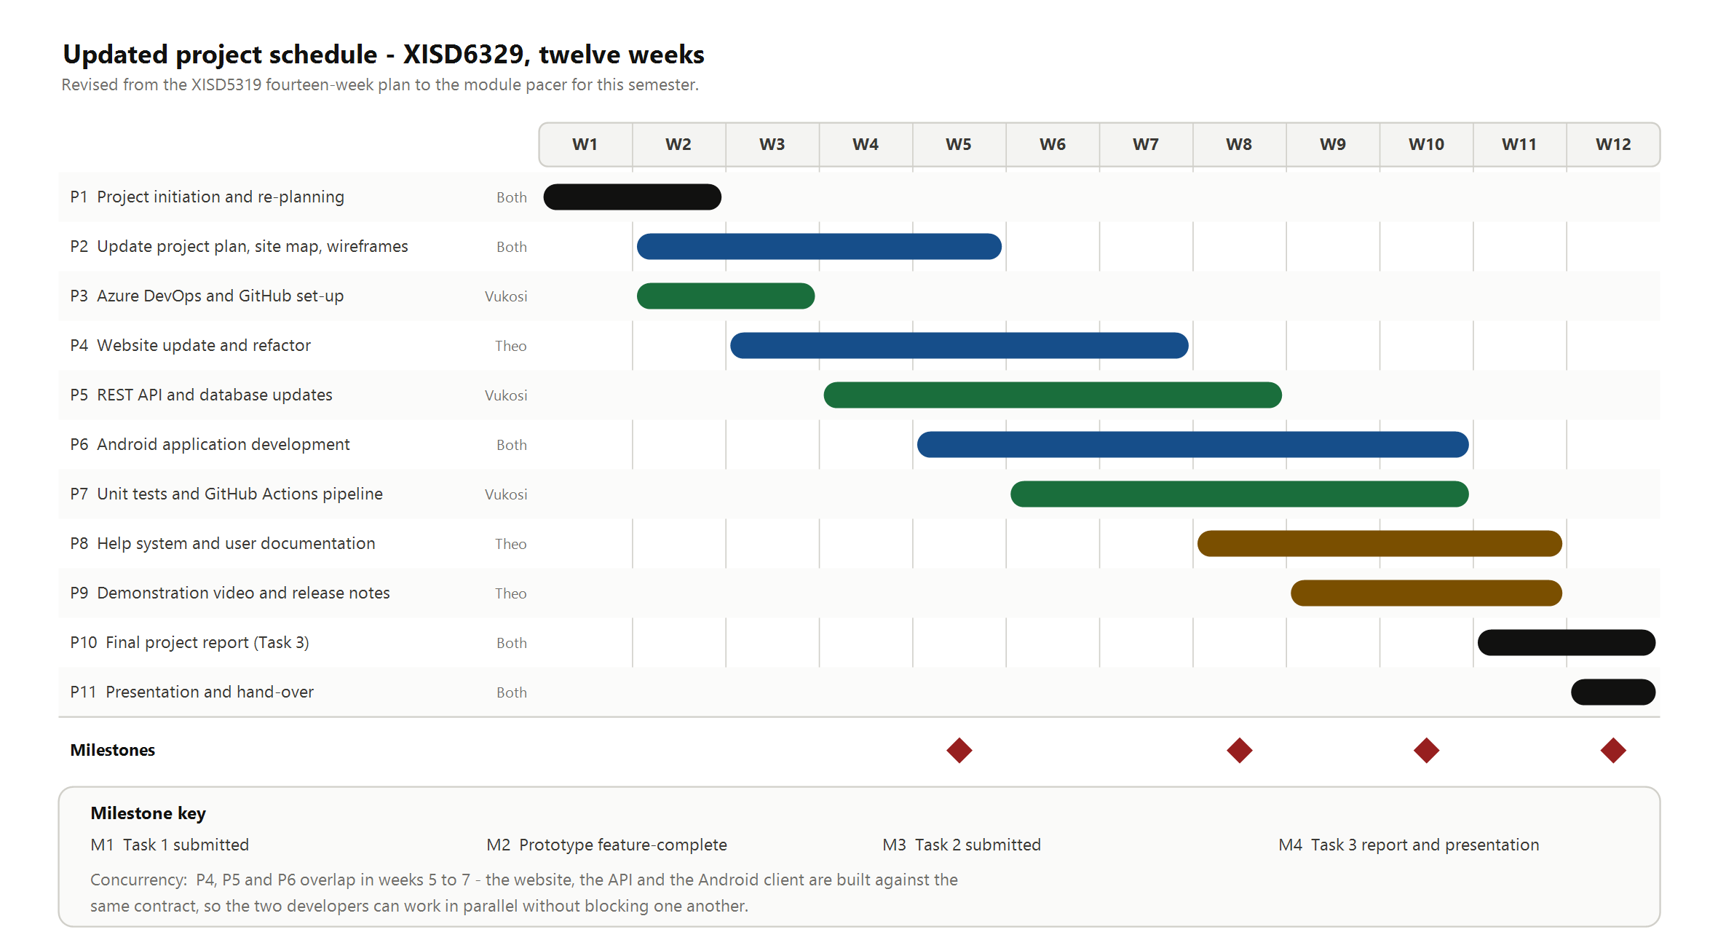
Figure 1: Updated twelve-week project schedule with phase bars, owners and the four assessment milestones
- M1 (week 5) is this Task 1 submission; M3 (week 10) is Task 2, the working prototype; M4 (week 12) is the final report and presentation.
- M2 in week 8 is an internal milestone, not an assessment point: it is the date by which every feature must exist in some form, leaving two weeks for defect repair rather than for new work.
- Bar colour indicates the owner shown in the column to the left of the chart: black for joint work, blue for Theo Golele, green for Vukosi Rikhotso, amber for documentation deliverables.

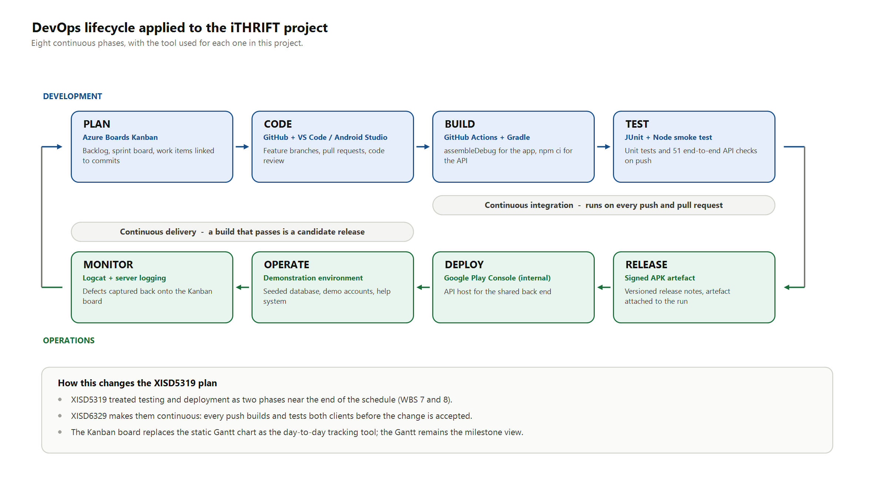
Figure 2: The eight-phase DevOps lifecycle as applied to the iTHRIFT project, with the tool used at each phase
- The upper row is the development loop and the lower row the operations loop; the two connect at each end, which is what makes the lifecycle continuous rather than sequential.
- Continuous integration spans Build and Test: no change is merged until both clients build and every test passes.
- Continuous delivery spans Release and Deploy: any build that clears integration is a candidate release, so a release is a decision rather than a scramble.

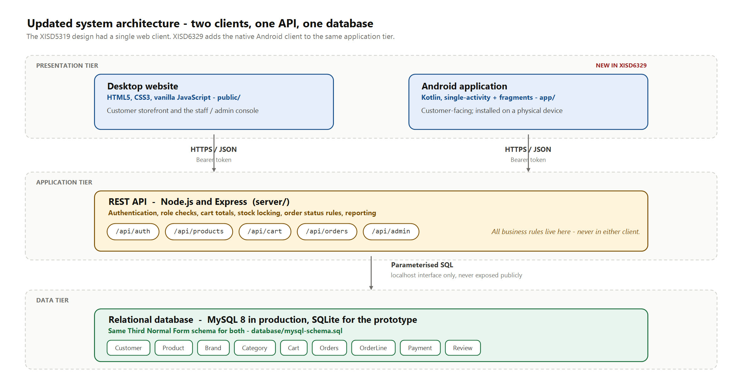
Figure 3: Updated three-tier architecture showing the website and the Android application sharing one REST API and one database
- Both clients authenticate the same way and carry a bearer token on every subsequent request, so a customer's account works identically on either surface.
- All business rules – cart totals, stock locking at checkout, order status transitions, role permissions – live in the application tier. Neither client is trusted to enforce them.
- The prototype runs against SQLite for portability during development; the production schema is MySQL 8. The table structure is identical, which is why the same queries serve both.

3.8 Updated risk register
The register is scored as it was in XISD5319: probability and impact are each rated 1 to 5, and the product gives a risk score banded as Low (1 to 6), Medium (8 to 12) or High (15 to 25). Three risks are new this semester and are marked accordingly.
Table 10: Updated risk register
ID | Risk | P | I | Score | Mitigation and contingency | Owner
R1 | A two-member group loses a member to illness or workload for a period | 3 | 5 | 15 High | Every deliverable has a named supporting member who can pick it up; no work item is held by one person for more than a week without a status note. Contingency: descope the reporting dashboard first, as it is the least assessed feature. | Both
R2 | The Android application will not run on a physical handset (new) | 3 | 5 | 15 High | Install on a real device from week 6, not week 11, and repeat at the end of every sprint. Contingency: borrow a second handset from a classmate and record the demonstration video early. | Theo
R3 | The API contract drifts and the two clients disagree about it (new) | 4 | 3 | 12 Med | The contract is agreed in work package 5.1 and any change to it requires a pull request that updates both clients together. Contingency: the smoke test fails loudly on a contract break, which surfaces it within one build. | Vukosi
R4 | PayFast integration proves harder than expected | 3 | 3 | 9 Med | Treat the live gateway as a stretch goal and build against a simulated payment capture that records the same data. Contingency: demonstrate EFT and cash on delivery, which need no third party. | Vukosi
R5 | The build pipeline itself becomes a blocker (new) | 3 | 3 | 9 Med | Keep the workflows small and cache dependencies; a workflow that is broken for more than a day is fixed before feature work continues. Contingency: run the same commands locally and record the output as evidence. | Vukosi
R6 | Scope creep from features that are interesting but unassessed | 4 | 2 | 8 Med | Anything not in Table 6 goes to a Later column on the board rather than into the sprint. Contingency: the weekly session with the lecturer is used to confirm priorities. | Both
R7 | Slow or absent client feedback delays a decision | 3 | 2 | 6 Low | Recommendations are put in writing with a stated default that applies if no answer is received within five working days. Contingency: proceed on the default and record it in Table 5. | Theo
R8 | Customer personal data is exposed | 2 | 5 | 10 Med | Passwords are hashed, transport is over HTTPS, roles are checked server-side, and no personal data is placed in a URL. Contingency: seed the demonstration database with fictitious customers only. | Vukosi
R9 | A third-party service is unavailable during the demonstration | 2 | 4 | 8 Med | Record the demonstration video in advance and seed the database so the walk-through does not depend on a live external call. Contingency: present from the recording. | Theo
R10 | Gaps in the team's experience with Kotlin or with Actions | 3 | 3 | 9 Med | Spike work items are timeboxed to one day; if a spike overruns, the group asks the lecturer in the weekly session rather than continuing alone. | Both
After mitigation, R1 and R2 are the two risks that remain in the High band. Both are addressed by the same discipline: nothing is left until the end. Physical-device testing and cross-cover on every deliverable are scheduled from week 6, which is early enough that discovering a problem is inconvenient rather than fatal.

3.9 Updated effort and cost budget
All tooling used on this project is open source or available on a free tier, so there are no licence or hardware costs. The budget is therefore an effort budget, costed at a notional junior developer rate of R150 per hour to express the value of the work. The module allocates 150 notional hours per student; with two students that is 300 hours, and the plan below commits 280 of them, leaving 20 hours of contingency.
Table 11: Updated effort and cost budget
Phase | Theo (h) | Vukosi (h) | Total (h) | Cost at R150/h
P1 Initiation and re-planning | 12 | 10 | 22 | R3 300
P2 Site map and wireframes | 26 | 14 | 40 | R6 000
P3 DevOps set-up | 6 | 16 | 22 | R3 300
P4 Website update and refactor | 38 | 6 | 44 | R6 600
P5 REST API and database | 6 | 40 | 46 | R6 900
P6 Android application | 26 | 30 | 56 | R8 400
P7 Automated testing | 8 | 20 | 28 | R4 200
P8 Help system and documentation | 14 | 2 | 16 | R2 400
P9 Release preparation | 10 | 10 | 20 | R3 000
P10 and P11 Report and presentation | 14 | 12 | 26 | R3 900
Total committed | 160 | 160 | 280 | R42 000
Contingency (notional hours not committed) | - | - | 20 | R3 000
The committed effort comes to R42 000, the same total as the XISD5319 budget, which is a useful check: the work has been redistributed across more phases rather than expanded. Against that cost the client receives two working sales channels, an administrative console that removes manual stock tracking, and a release pipeline that makes future changes cheap. A single month of orders that would otherwise have been lost to an unanswered Instagram message covers a meaningful share of it.

3.10 Response to the XISD5319 Task 1 feedback
The XISD5319 project plan was marked at 62 out of 100 and the corrections were made in the final report for that module. Those corrections are carried into this plan rather than repeated, and Table 12 records where each one now sits so the improvement is traceable.
Table 12: Carry-over of the XISD5319 Task 1 feedback into this plan
Criterion and prior mark | What was wrong | Where it is addressed now
Work breakdown structure (0/10) | Tasks and detail were missing entirely | Section 3.4: eleven phases, each broken into work packages with duration, predecessor and owner
Gantt chart and interpretation (5/10) | The interpretation was limited | Section 3.5: the chart is rebuilt for twelve weeks, with the critical path, the concurrency and the milestone positions explained in the text
Risk management (13/20) | Mitigation was appropriate but shallow | Section 3.8: scored register with probability, impact, banding, a separate contingency and a named owner on every row
Technical feasibility (8/15) | Resources were listed but not justified | Section 3.7: the architecture figure states what each tier is for and why the stack makes the build feasible for a two-person team
Economic feasibility (12/15) | Minor arithmetic errors | Section 3.9: the budget reconciles to R42 000 and is stated against the 300 notional hours the module allocates
Formatting and layout (9/15) | Formatting was inconsistent | This document uses one heading hierarchy, numbered and captioned figures and tables, a running footer, and generated contents and figure lists

4. Site map

4.1 How the site map was derived
The site maps below were not drawn from imagination. Each node corresponds to a route that the front-end router resolves, or to a fragment that the Android activity hosts. Producing them this way means the maps double as a specification for Task 2: a route on the map that does not exist in the build is an outstanding work item, and a route in the build that is not on the map is scope that was never agreed.
Both maps are organised by who is allowed to reach a screen rather than by subject matter, because access is the property that most often goes wrong in an e-commerce system.

4.2 Website site map
The website has three access tiers. Anyone may browse the catalogue and read reviews. A signed-in customer additionally reaches the cart, checkout, order history and account screens. Staff and administrators reach the console, and within the console the Customers section is restricted further to administrators alone. The map is drawn in Figure 4.

4.3 Mobile application site map
The application is a single-activity design. One activity hosts a fragment container and a bottom navigation bar with five tabs, and every other screen opens on top of the current tab through the fragment back stack. This keeps the navigation model shallow, which matters on a phone: the customer is never more than two taps from the catalogue. The map is drawn in Figure 5. The two maps are placed on the following two pages so that they can be compared directly; the route and navigation reference tables then follow.
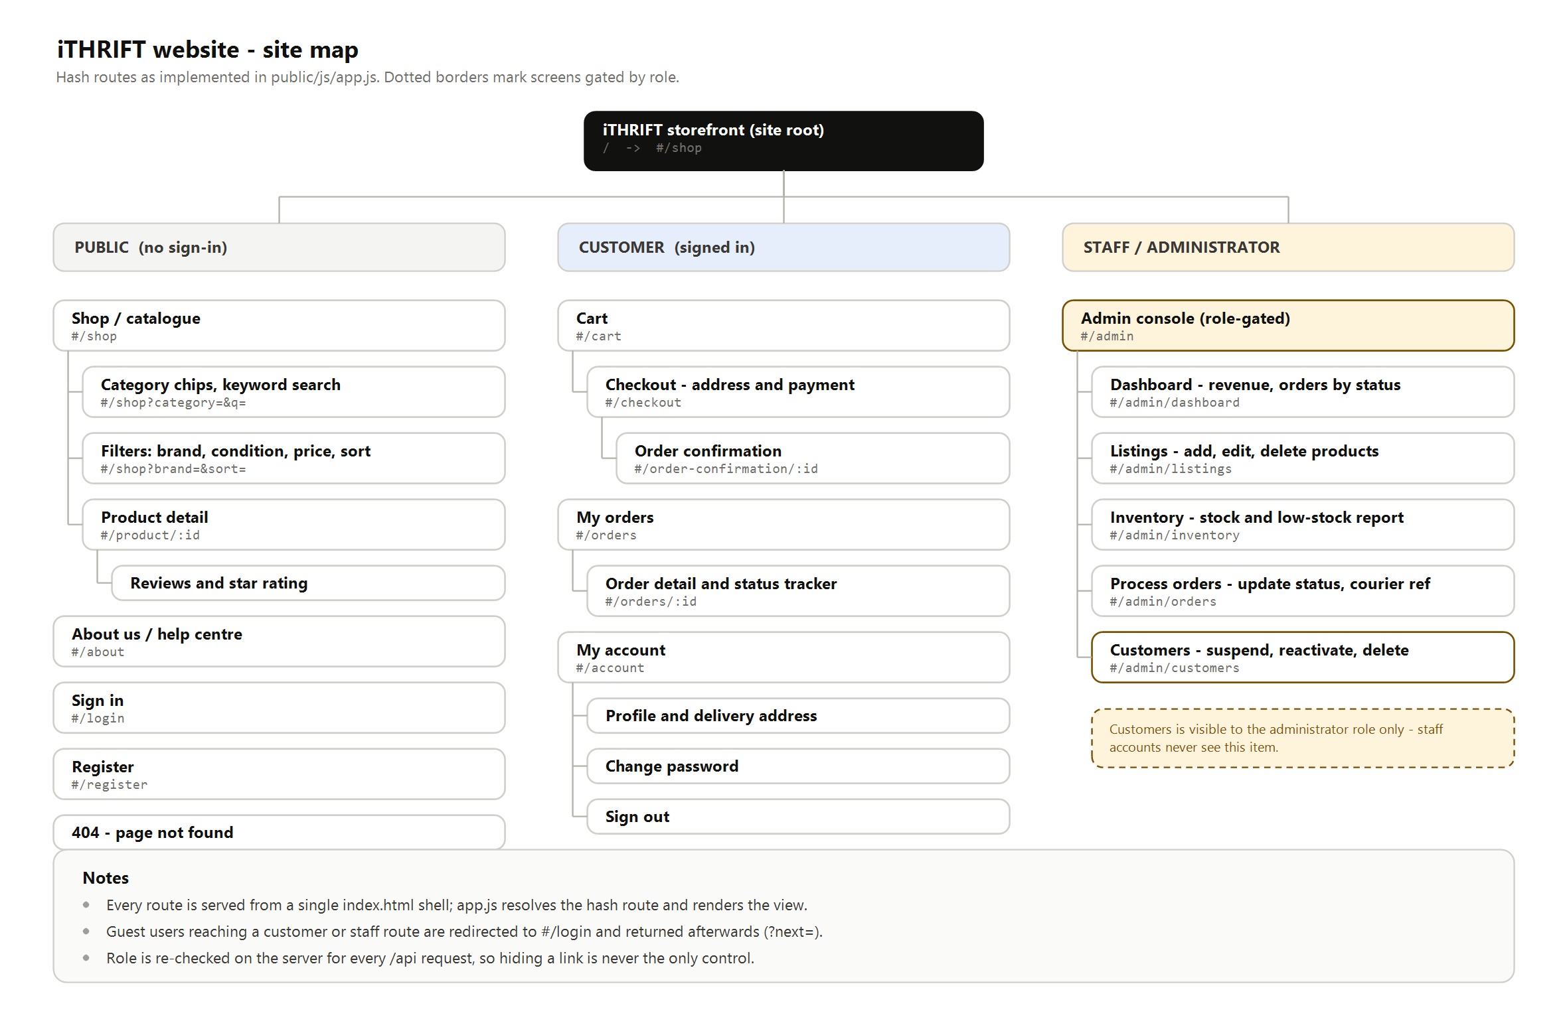
Figure 4: Site map of the iTHRIFT website, organised by access tier
- The site is a single-page application: one HTML shell is served, and the router resolves the hash route and renders the matching view. The routes shown are therefore real addresses that can be linked to and bookmarked.
- A guest who follows a link to a customer or staff route is sent to the sign-in screen and returned to the original destination afterwards, rather than being shown an error.
- Role is checked again on the server for every API request behind these screens. The site map shows what a user can see; it is not what enforces it.

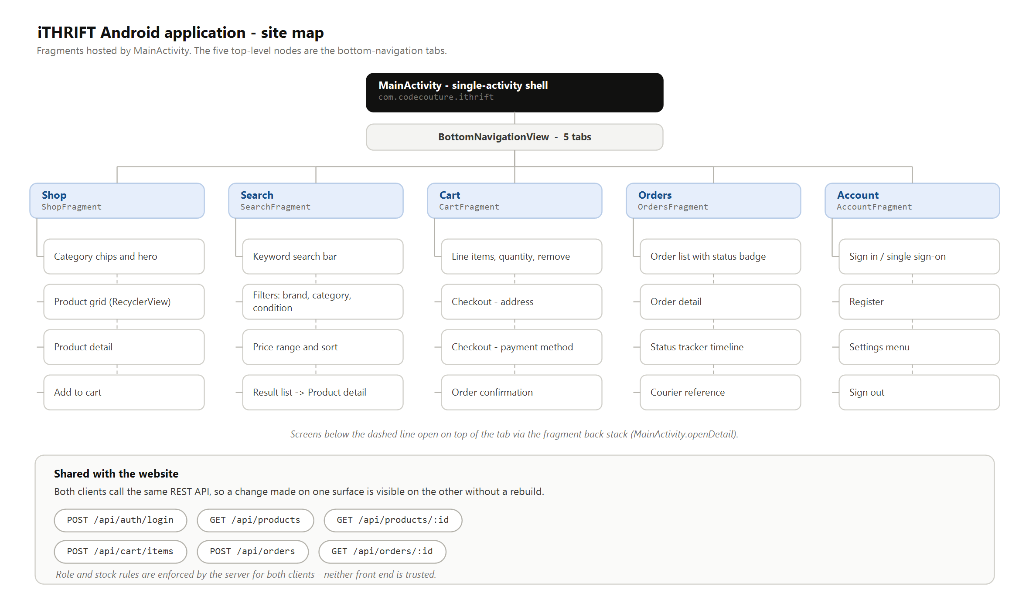
Figure 5: Site map of the iTHRIFT Android application, with the five bottom-navigation tabs as the top-level nodes
- The five tabs are the only top-level destinations. Screens below the dashed line are detail screens pushed onto the back stack, so the system back button always returns to where the customer came from.
- The application carries no administrative screens at all, which is the decision recorded in Table 4.
- The endpoints listed at the foot of the figure are shared with the website, so a change to a business rule takes effect on both surfaces without either being rebuilt.

4.4 Website route reference
Table 13: Website routes, access level and purpose
Route | Access | Purpose
#/shop | Public | Catalogue with category chips, keyword search and filters
#/product/:id | Public | Product detail, image gallery, condition and stock, reviews
#/about | Public | About the business, condition grading, delivery and returns
#/login | Public | Sign in, with single sign-on options
#/register | Public | Create a customer account
#/cart | Customer | Cart line items, quantity, running total
#/checkout | Customer | Delivery address and payment method
#/order-confirmation/:id | Customer | Order reference, total and delivery estimate
#/orders | Customer | Order history with a status badge on each order
#/orders/:id | Customer | Order detail, status tracker and courier reference
#/account | Customer | Profile, delivery address, password, sign out
#/admin/dashboard | Staff | Revenue, order counts, revenue by brand and category
#/admin/listings | Staff | Add, edit, mark out of stock and delete listings
#/admin/inventory | Staff | Stock levels and the low-stock report
#/admin/orders | Staff | Order queue, status updates, courier reference capture
#/admin/customers | Admin | View, suspend, reactivate and delete customer accounts

4.5 Mobile navigation reference
Table 14: Android application screens, host fragment and how each is reached
Screen | Fragment | Reached from
Shop | ShopFragment | Bottom navigation, and the landing screen on launch
Search and filters | SearchFragment | Bottom navigation
Product detail | ProductDetailFragment | Product card in Shop or in a search result
Cart | CartFragment | Bottom navigation, or after adding an item
Checkout | CheckoutFragment | Proceed to checkout, from the Cart
Order confirmation | OrderConfirmationFragment | Confirm and pay, from Checkout
Orders | OrdersFragment | Bottom navigation, or Track order from confirmation
Order detail and tracker | OrderDetailFragment | An order row in Orders
Account, sign in and settings | AccountFragment | Bottom navigation, or the header sign-in button

4.6 Differences between the two navigation models
The two maps are deliberately not identical, and the differences are design decisions rather than accidents.
- Search is a tab on the phone and a control on the website. On a large screen the filter panel can sit beside the results; on a phone it needs the whole screen, so it earns its own destination.
- Sign-in is a page on the website and a section of the Account tab on the phone. A phone user expects the account tab to handle identity; a web user expects a sign-in page they can link to.
- The website exposes checkout as its own route so it can be returned to after a payment redirect. The application treats checkout as a screen on the cart stack, because there is no redirect to come back from.
- The console exists only on the website. This is the single largest structural difference and follows directly from Table 4.

5. Wireframes

5.1 Conventions used
The wireframes that follow are low-fidelity by intent. They fix layout, hierarchy and the position of every control, and they deliberately do not fix final photography, copy or colour, which are settled during the build. The following conventions apply throughout.
- A grey rectangle crossed with two diagonals is an image placeholder. The label inside states what the image is.
- Grey bars stand for body copy whose exact wording is not yet fixed.
- A solid dark pill is the primary action on that screen; an outlined pill is a secondary action. There is never more than one primary action visible at once.
- A numbered amber marker is a note about behaviour that the drawing alone cannot show.
- Placeholder values are written as R000 for money and ORD-0000 for references, so that no wireframe is mistaken for real data.
Each wireframe is placed on its own landscape page so that the labels remain readable. The full-resolution image files are also in the repository under docs/task1/figures, and can be opened at their original size if any detail needs to be inspected.

5.2 Website wireframes
Seven screens are wireframed, in Figures 6 to 12. Together they cover every route in Table 13 apart from the About page, which is static content, and the 404 fallback.

5.3 Android application wireframes
Nine application screens are wireframed across three sheets, in Figures 13 to 15, grouped by the task the customer is performing. All are drawn at a 360 by 760 density-independent pixel viewport, which is representative of the mid-range Android handsets common in South Africa. The full wireframe set follows on the next ten pages, website screens first and then the application; each sheet carries its caption and the design decisions behind that screen.
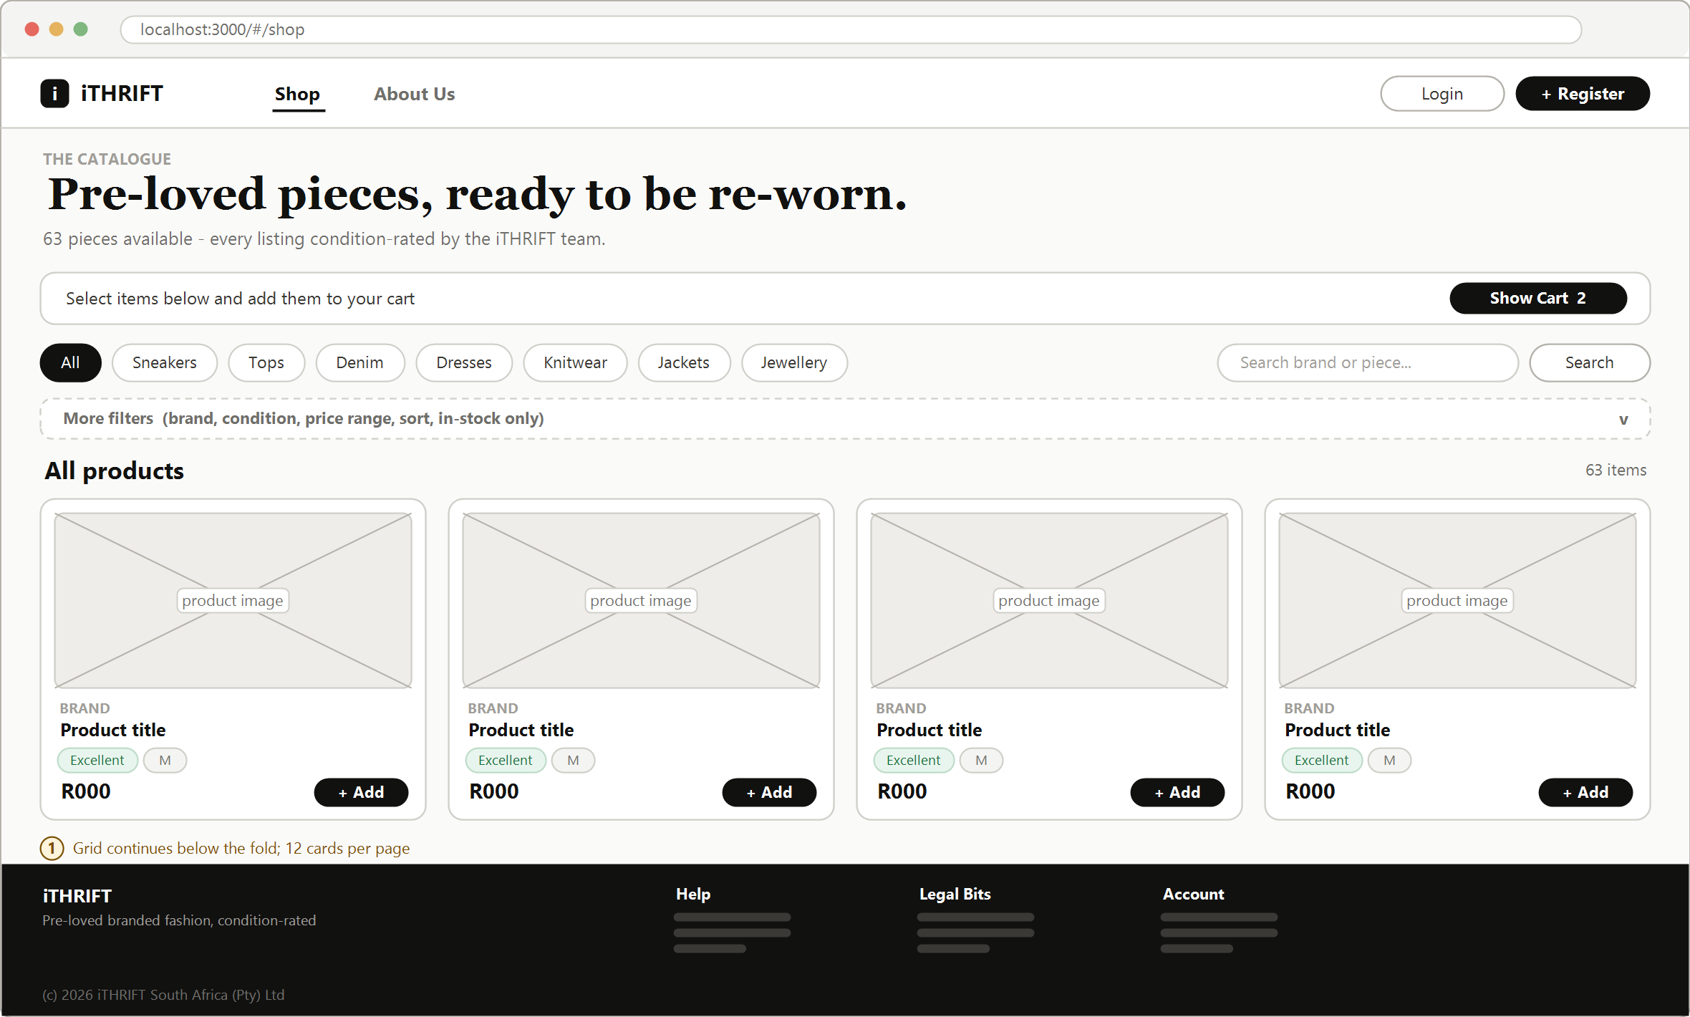
Figure 6: Website: catalogue and landing screen (#/shop)
- The catalogue is the landing screen. A visitor sees stock before being asked to do anything, which is the single most important decision on the site.
- Filtering is layered: category chips are always visible because they carry most of the traffic, while brand, condition, price and sort are collapsed behind More filters so the controls do not crowd the products.
- Every card carries the condition grade. Condition is the deciding factor when buying second-hand, so it is shown at the point of choice rather than one click away.
- Add is available directly from the card. A visitor who is not signed in is sent to sign-in and returned to the catalogue with the item still intended.

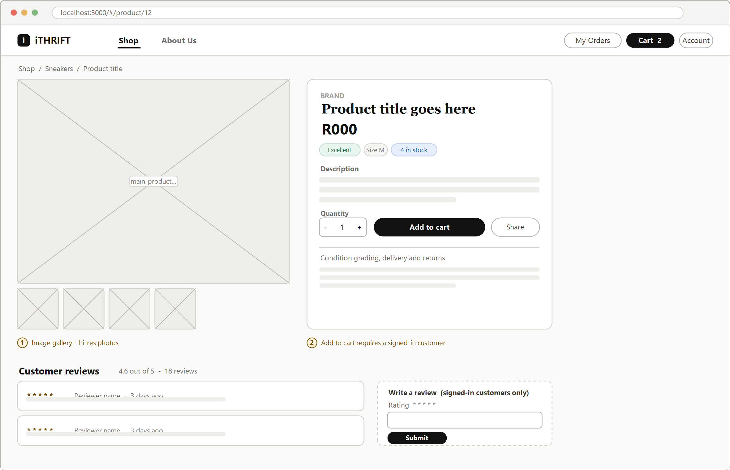
Figure 7: Website: product detail with gallery and reviews (#/product/:id)
- The gallery occupies the left half. Second-hand stock is one-of-a-kind, so photographs carry the weight that a size chart carries in ordinary retail.
- Condition, size and stock sit together directly under the price, because those three answer the customer's first question: is this the right item and can I still get it?
- Reviews are shown below the fold and the review form is restricted to signed-in customers, which satisfies UC13 without inviting anonymous posts.

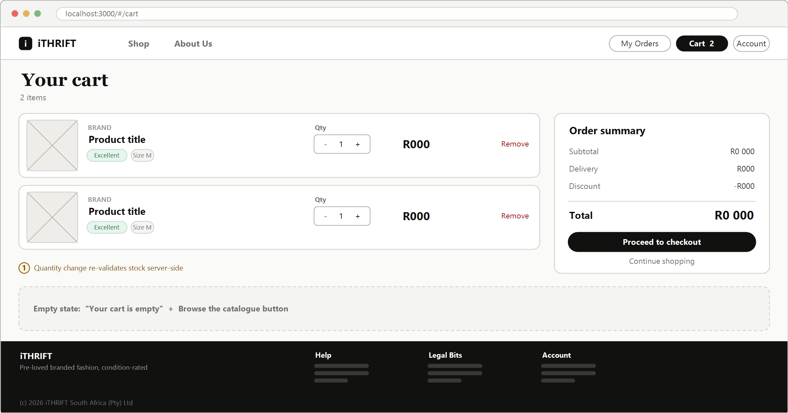
Figure 8: Website: cart with order summary (#/cart)
- The summary panel is fixed to the right of the line items so the total stays visible while quantities are changed.
- Changing a quantity re-validates stock on the server. A customer cannot increase a quantity beyond what is actually available, because the client is not trusted to know the stock level.
- The empty state is specified here rather than left to the build, since an unstyled empty cart is a common way for a prototype to look unfinished.

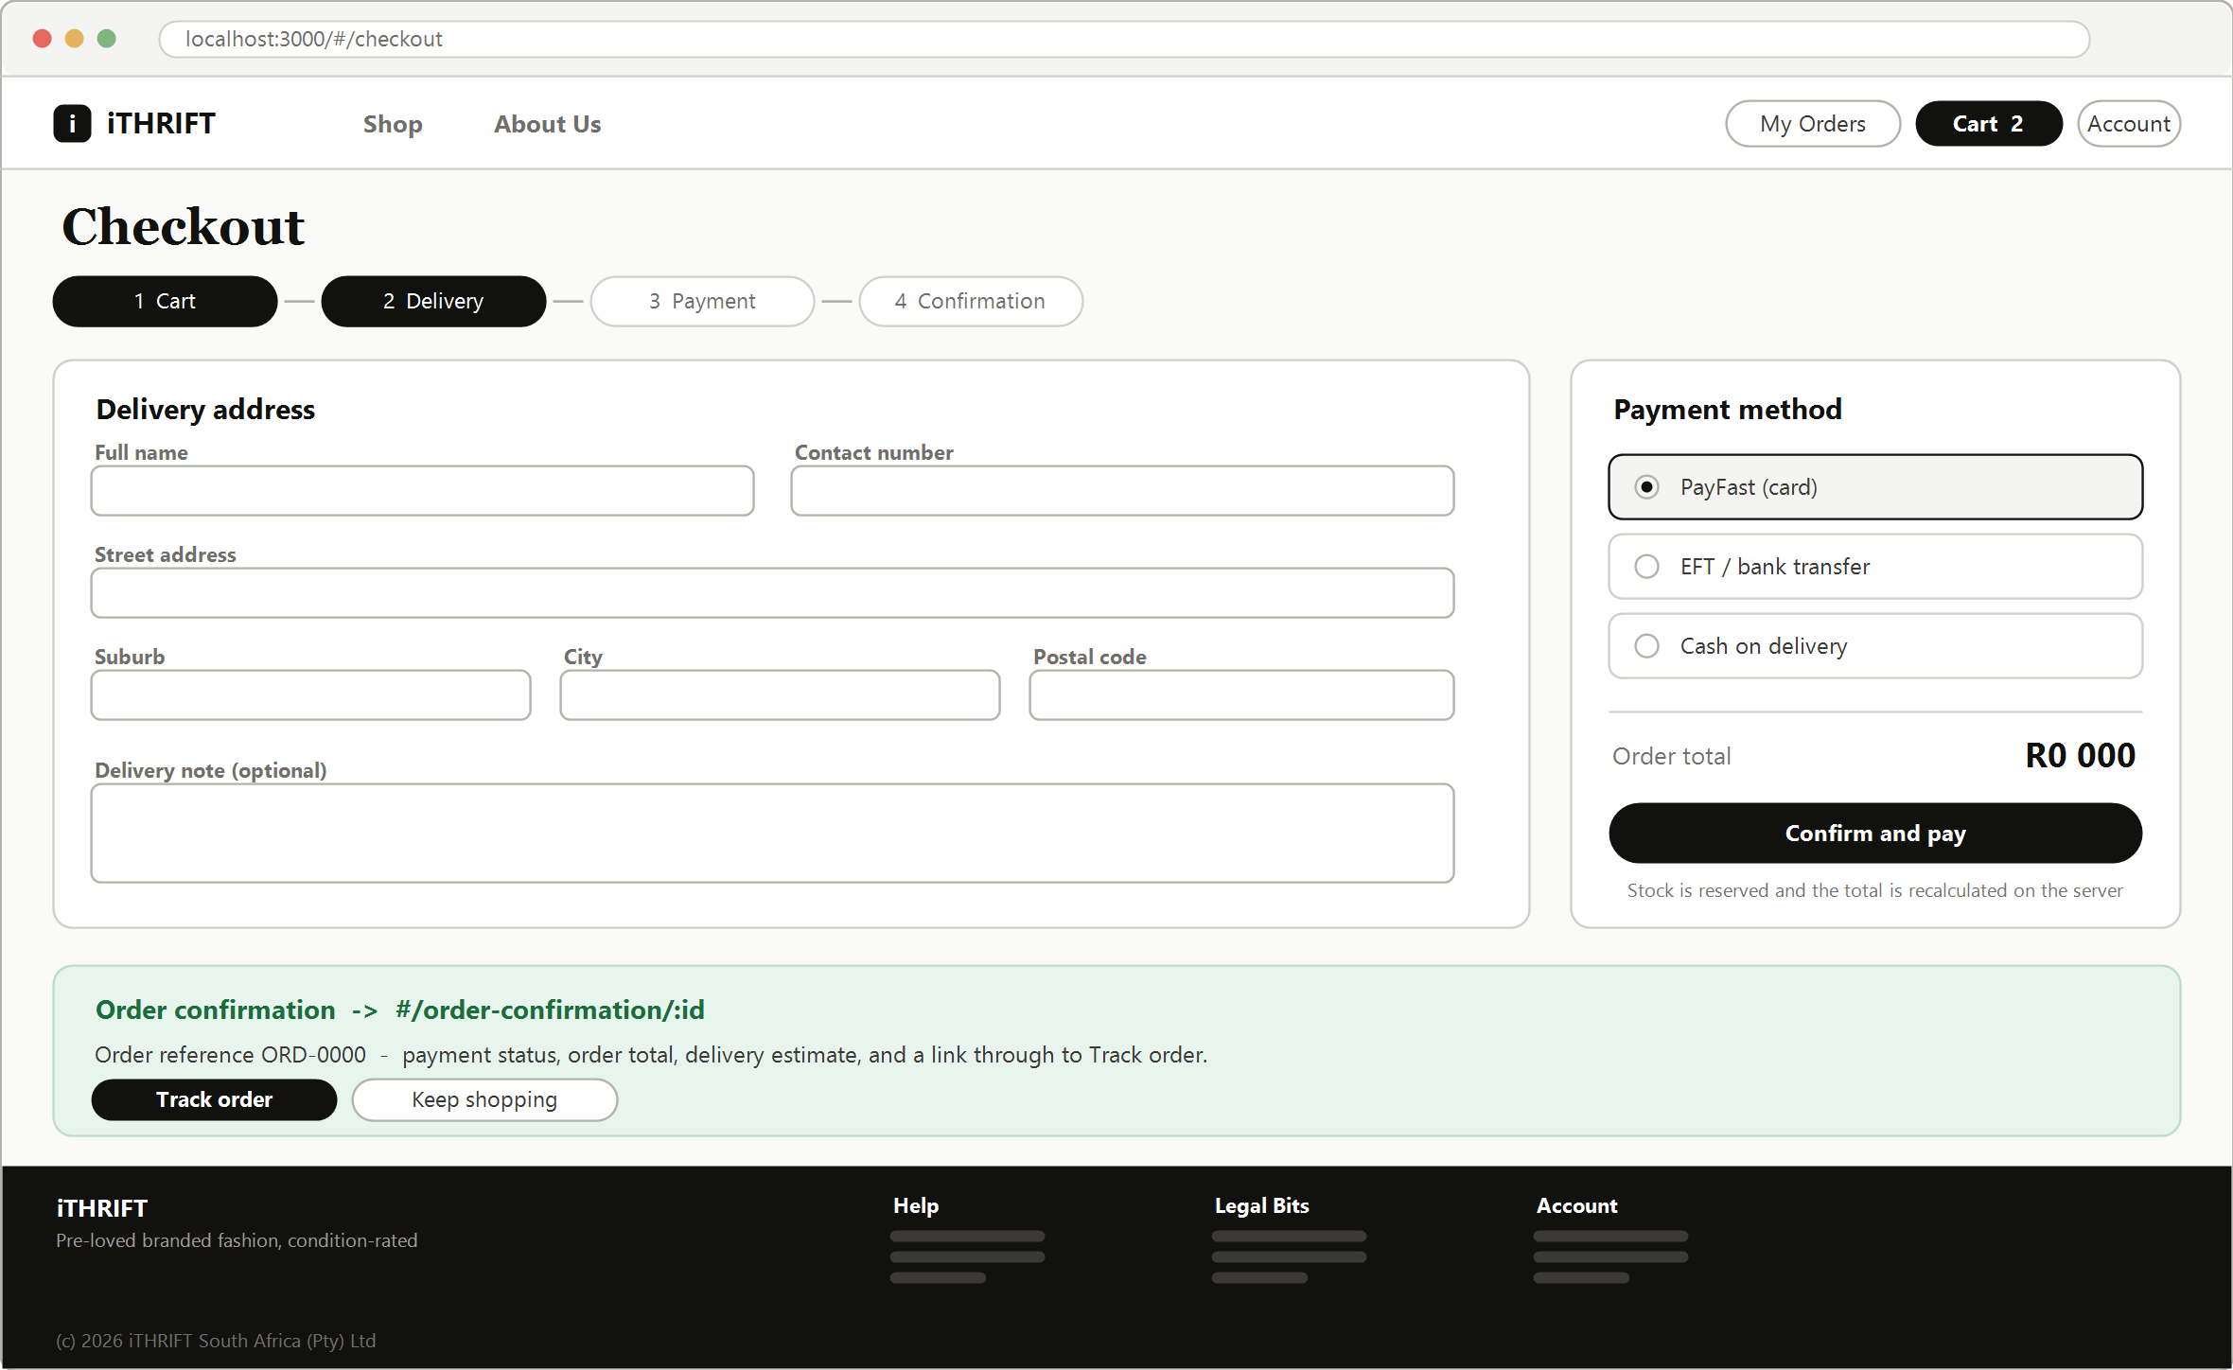
Figure 9: Website: checkout and order confirmation (#/checkout, #/order-confirmation/:id)
- A four-step indicator runs across the top. Showing the customer how many steps remain is a well-established way of reducing abandonment at checkout.
- Three payment methods are offered. Cash on delivery and EFT matter in the South African market, where a meaningful share of customers do not want to enter card details.
- The order total is recalculated on the server at the moment the order is placed, and stock is locked in the same transaction, which is what stops two customers buying the same one-off item.
- The confirmation state is drawn on the same sheet because it is the immediate consequence of the primary action, and the two are best reviewed together.

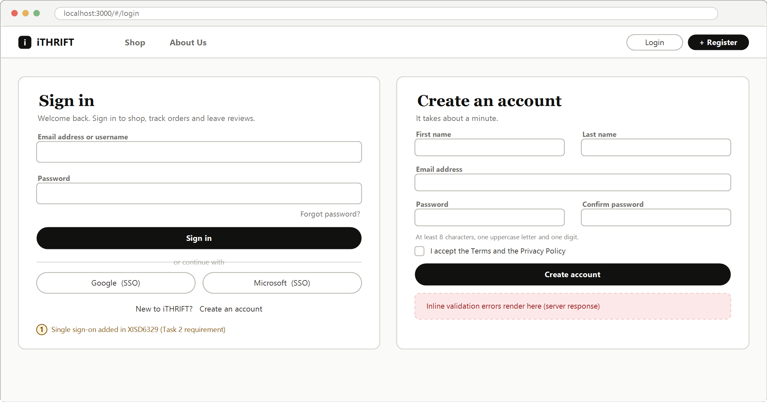
Figure 10: Website: sign in and registration (#/login, #/register)
- Both screens are shown together because they are two halves of one decision, and the link between them must be obvious on each.
- Single sign-on is included here because the module requires it in Task 2. Designing it in now avoids retrofitting a second button into a finished screen.
- Password rules are stated next to the field rather than revealed by an error after submission.
- Validation errors are rendered inline from the server response. Client-side validation is a convenience only; the server is authoritative.

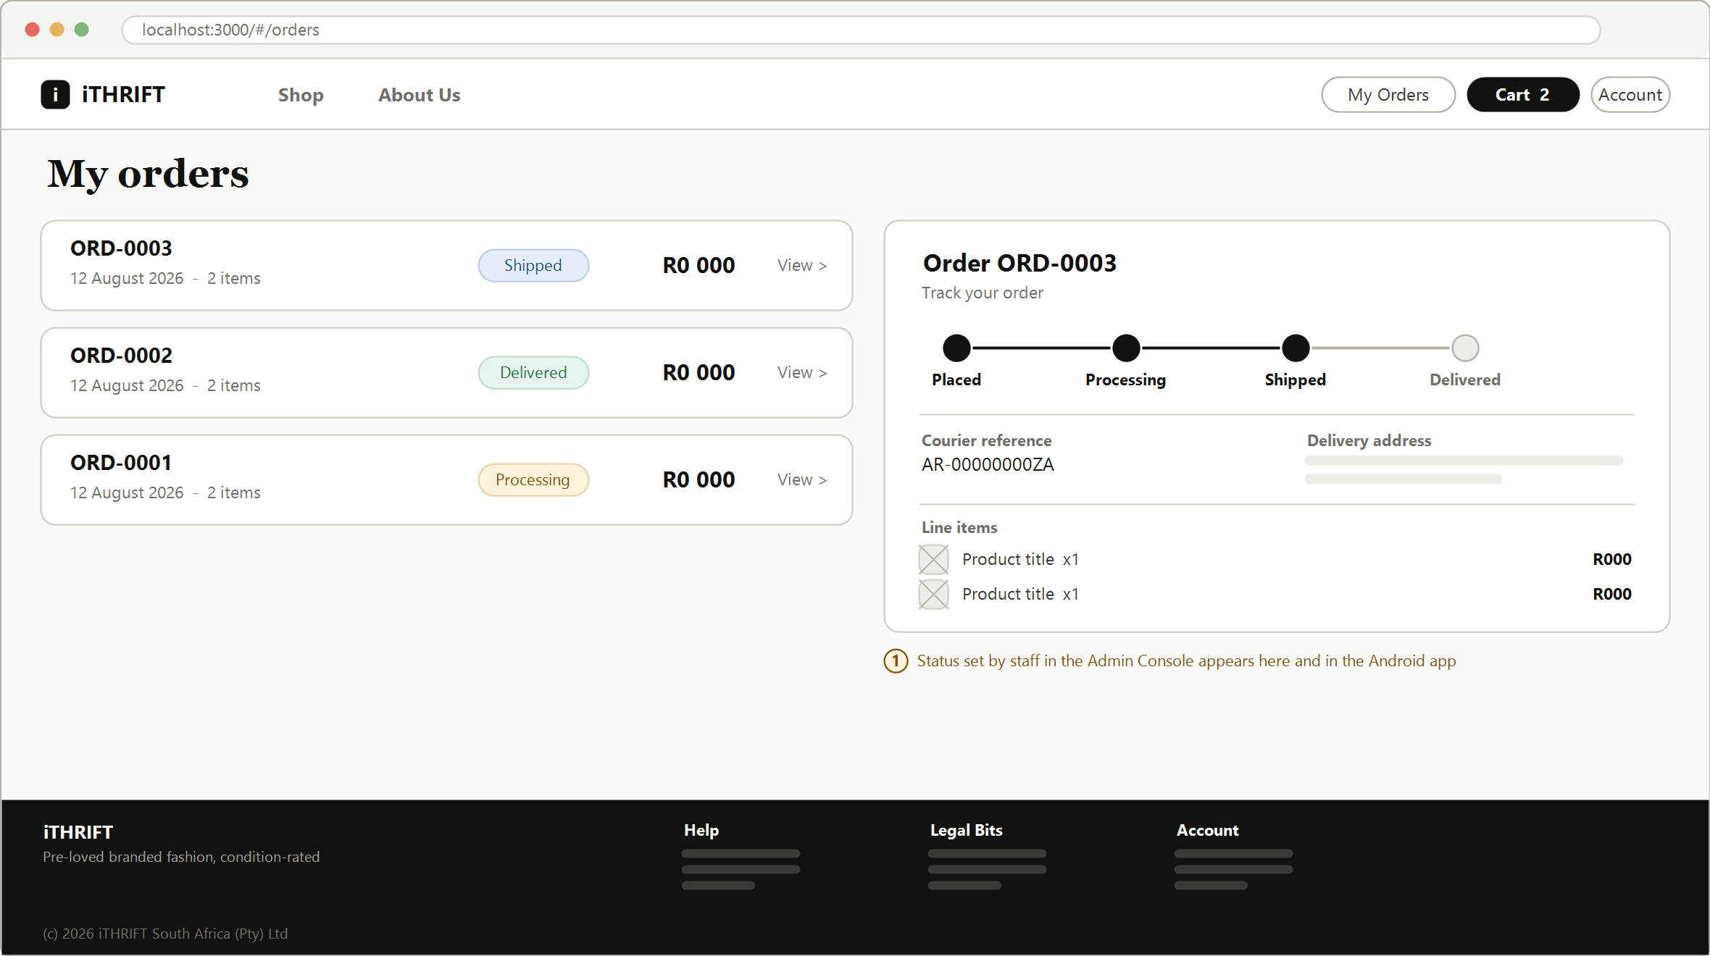
Figure 11: Website: order history and order tracking (#/orders, #/orders/:id)
- The list and the detail are shown side by side, which is how the screen behaves on a wide viewport; on a narrow one the detail becomes its own page.
- The status tracker is a horizontal timeline with completed stages filled. It is the same four stages that staff set in the console, so the customer and the business are always looking at one truth.
- The courier reference appears only once staff have captured it, rather than showing an empty field that looks like a fault.

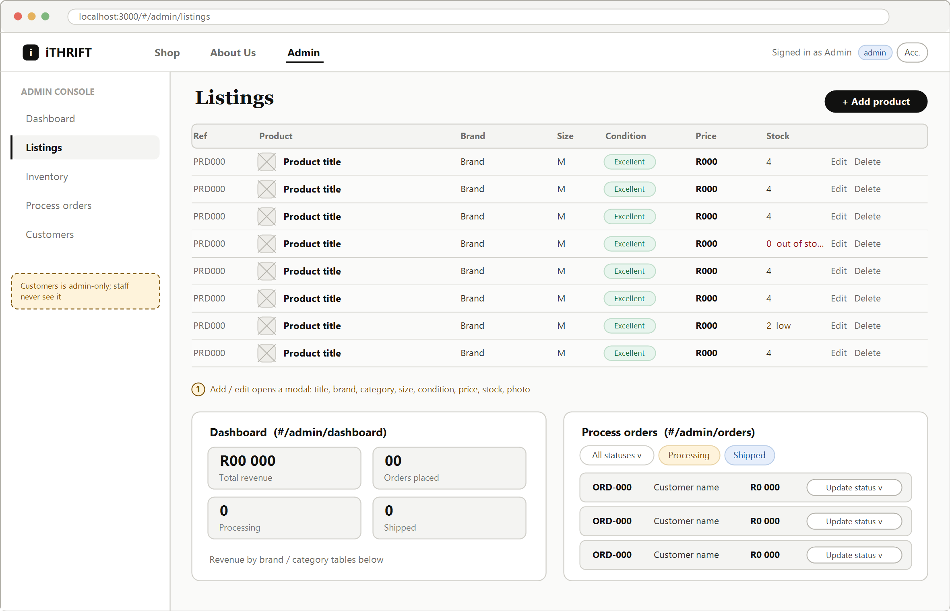
Figure 12: Website: staff and administrator console (#/admin)
- A persistent left sidebar carries the five console sections. Customers is rendered for administrators only; a staff account never sees the item, and the server refuses the request even if the address is typed by hand.
- Listings is a dense table rather than a card grid, because staff scan and edit rather than browse.
- Stock is colour-coded in the table: red at zero, amber at three or fewer. The low-stock list on the Inventory screen is generated from the same rule.
- The dashboard and order-processing panels are drawn at the foot of the sheet to show all three console sections in one view.

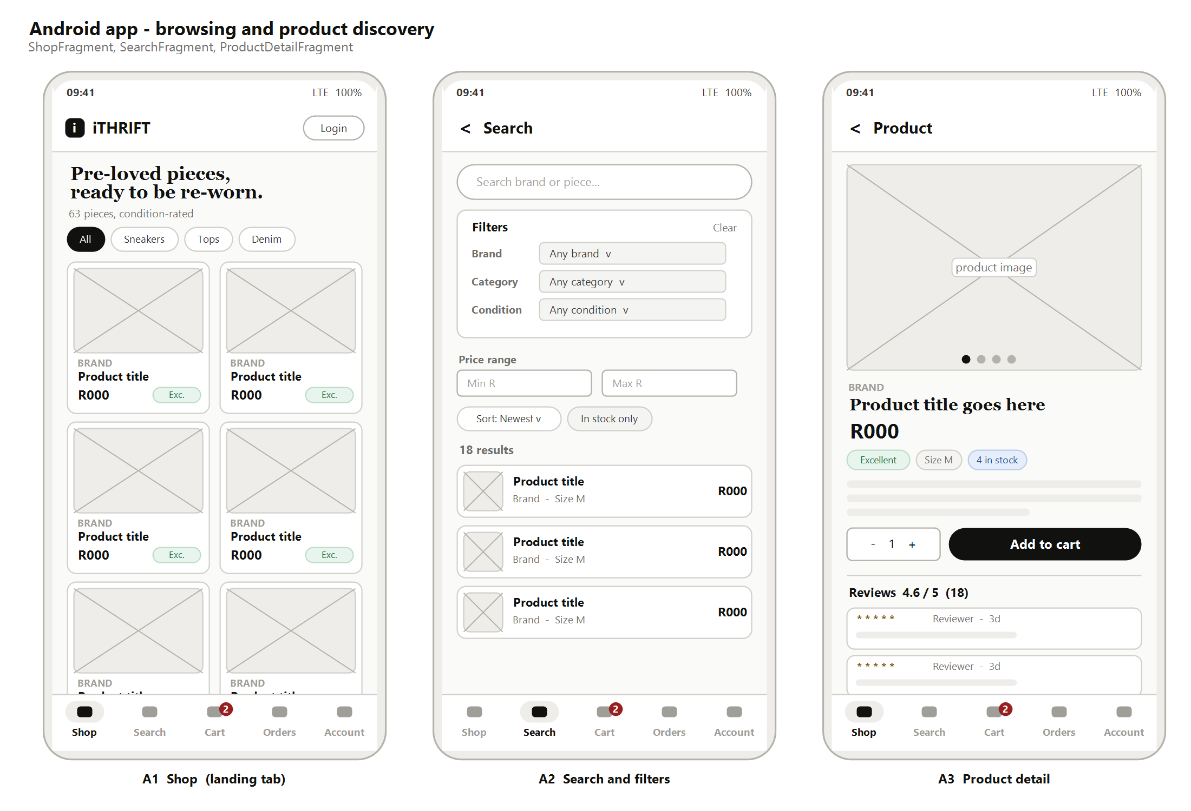
Figure 13: Android application: Shop, Search and Product Detail
- The bottom navigation carries five tabs and is present on every root screen. The cart tab shows a badge with the item count so the customer never loses track of what is in it.
- The catalogue uses a two-column grid. One column wastes the screen; three make the photographs too small to judge condition.
- Search is its own tab with the filters on the screen rather than behind a menu, which is the main structural difference from the website.
- The product detail screen keeps the quantity selector and Add to cart together at a thumb-reachable height rather than at the top of the screen.

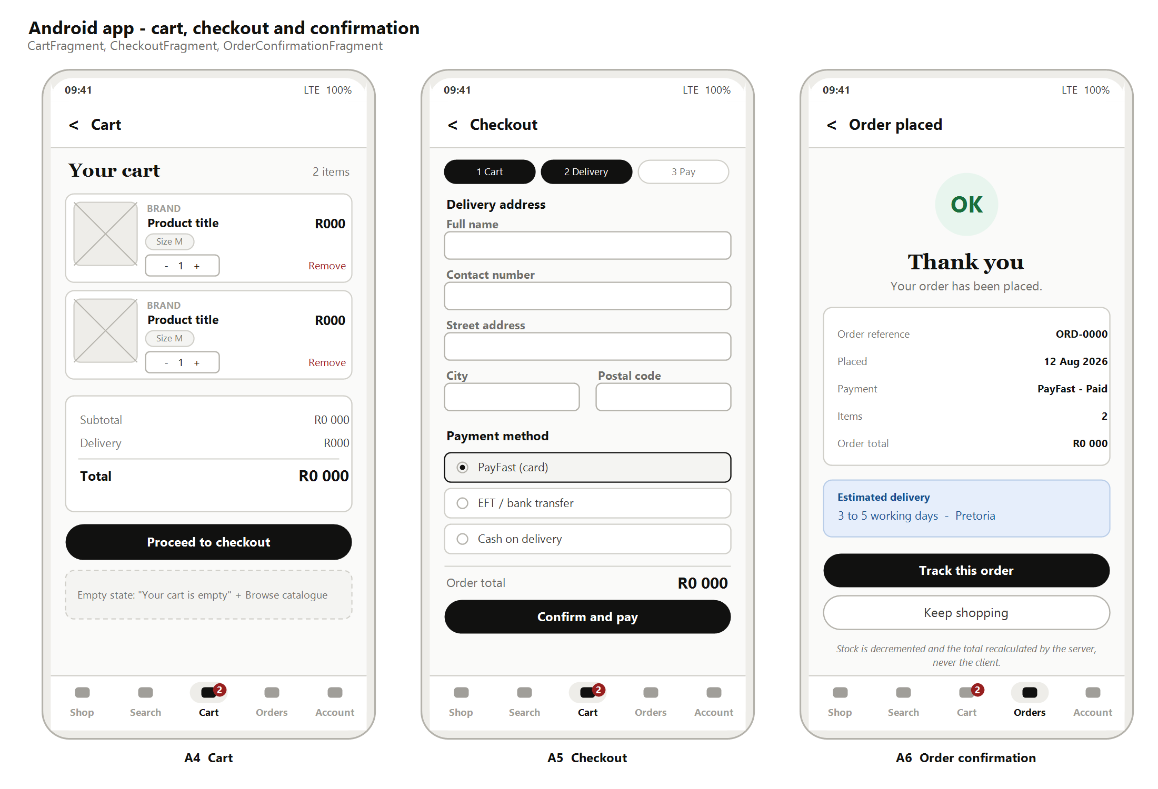
Figure 14: Android application: Cart, Checkout and Order Confirmation
- The cart uses full-width rows rather than the website's summary panel, because there is no room for a side panel; the total sits directly above the primary action.
- Checkout compresses to three steps on the phone against four on the website, by combining the cart review into the delivery step.
- The confirmation screen leads with the order reference, since that is what the customer will quote if they contact the shop.
- Both Track this order and Keep shopping are offered, because the customer's next intention is genuinely one or the other.

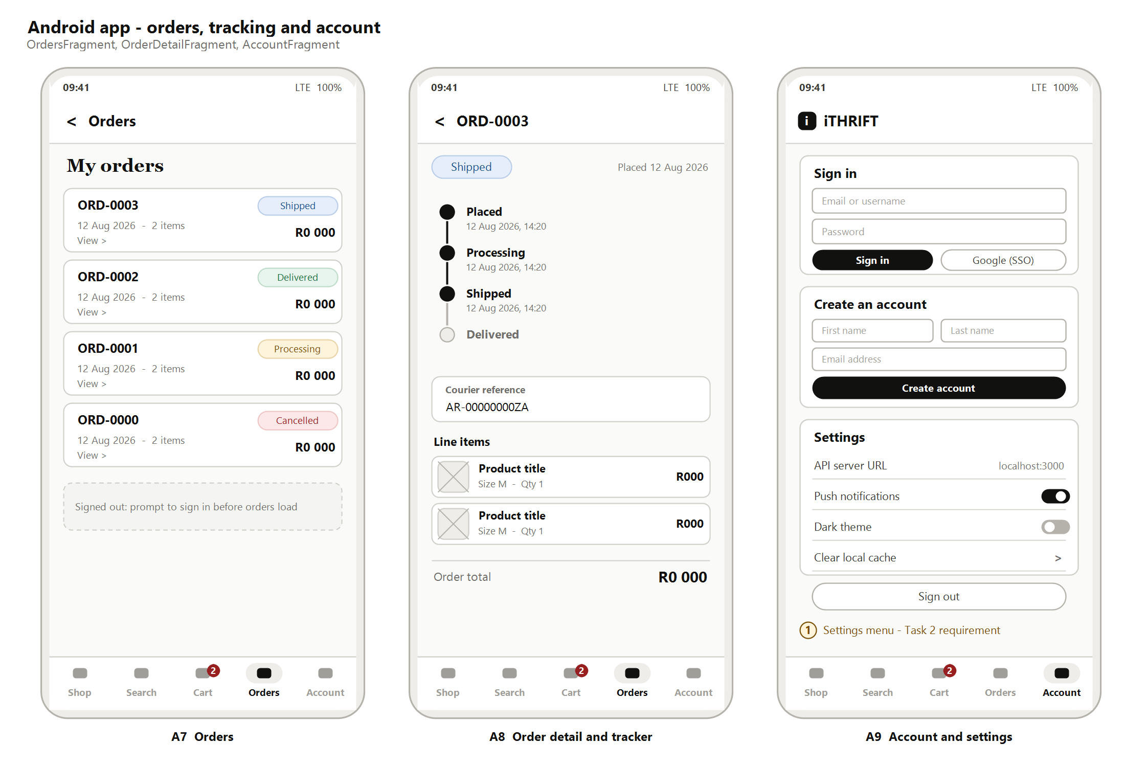
Figure 15: Android application: Orders, Order Detail and Account with settings
- The status tracker is vertical on the phone and horizontal on the website. The stages and their meaning are identical; only the axis changes.
- Sign-in and registration share the Account tab. A signed-out customer sees both cards; a signed-in customer sees their profile and the settings list instead.
- The settings screen satisfies the Task 2 requirement for a settings menu that makes sense for the application, covering the API endpoint, notifications, theme and local cache.
- The Orders tab shows a prompt to sign in rather than an empty list when the customer is signed out, which distinguishes "you have no orders" from "we do not know who you are".

5.4 Traceability from screen to requirement
Table 15 checks the wireframes against the fourteen use cases carried forward from the XISD5319 requirement analysis. Every use case is served by at least one screen, and no screen exists that serves none.
Table 15: Traceability of use cases to wireframed screens
Use case | Website screen | Application screen
UC1 Register a customer account | Figure 10 | Figure 15
UC2 Sign in | Figure 10 | Figure 15
UC3 Browse the catalogue | Figure 6 | Figure 13
UC4 Search and filter listings | Figure 6 | Figure 13
UC5 Manage the cart | Figure 8 | Figure 14
UC6 Place an order at checkout | Figure 9 | Figure 14
UC7 Make a payment | Figure 9 | Figure 14
UC8 Track order status | Figure 11 | Figure 15
UC9 Manage product listings | Figure 12 | Not applicable
UC10 Process incoming orders | Figure 12 | Not applicable
UC11 Manage user accounts | Figure 12 | Not applicable
UC12 Generate reports | Figure 12 | Not applicable
UC13 Leave a review and rating | Figure 7 | Figure 13
UC14 View order history | Figure 11 | Figure 15

6. Repository, file and folder structure

6.1 Repository
All project files are held in a single public GitHub repository at https://github.com/ST10439408-VRIKHOTSO/iTHIFT. The repository was initialised with a README and holds the website, the REST API, the Android application, the database schema, the automated tests and this documentation. No files are submitted as archives, in line with the module requirement.

6.2 Folder structure
The structure separates the three deliverables at the top level, so a reader can find the website without reading past the application, and so the build workflows can watch the right paths. Everything the browser downloads lives under public, which is also the folder the web server treats as its root.
ithrift/
public/ web root - everything the browser downloads
index.html single-page shell for every route
css/
style.css design tokens, components and layout
js/
app.js router, session, shared helpers
views-shop.js catalogue, product detail, cart, checkout
views-auth.js sign in, register, account, orders
views-admin.js dashboard, listings, inventory, orders, customers
images/
brand/ logo and storefront photography
products/ product photography, one file per listing
mobile/ installable web build of the storefront
app/ android application (kotlin)
src/main/java/com/codecouture/ithrift/
data/ api client, models, session, typed results
ui/shop/ ui/search/ ui/cart/ ui/orders/ ui/account/
src/main/res/ layouts, drawables, values
server/ rest api (node and express)
routes/ auth, products, cart, orders, admin
middleware/ authentication and role checks
utils/ password hashing, references, images
database/
mysql-schema.sql production schema, third normal form
test/
smoke-test.js end-to-end checks across the api surface
docs/
task1/ this document and its figures
.github/workflows/ automated build and test pipelines
README.md

6.3 Naming conventions
One convention is applied to every file and folder that the web server serves, and it is the convention the rubric asks for.
- No capital letters. URLs are case-sensitive on most web servers, so a capital in a filename is a broken link waiting to happen.
- No spaces. A space becomes %20 in a URL, which is ugly and error-prone.
- No special characters. Words are separated by a single hyphen, as in dark-blue-straight-jeans.jpg.
- Names describe content, not position. A product image is named for the product, never for where it happens to appear on a page.
Two deliberate exceptions exist. README.md is capitalised because that is the name GitHub recognises and renders on the repository home page, and the Android source under app follows the Kotlin and Android conventions of package-style lowercase directories with PascalCase class files. Neither is served over HTTP, so neither is affected by the reasoning above.

6.4 README
The README is the entry point for anyone opening the repository, including the lecturer and the external moderator. It covers what the project is and who it is for, the technology used in each tier, how to install and run the API, the website and the application, the demonstration accounts for each role, the API endpoints, how to run the tests, the folder structure, and the release notes. It is updated in the same pull request as any change that makes part of it untrue, which is condition four of the definition of done in Table 9.

6.5 Automated testing
Two GitHub Actions workflows are committed under .github/workflows and run on every push and pull request to the main branch.
- The API and website workflow installs dependencies from the lock file, starts the server against a freshly seeded database, and runs the end-to-end smoke test. The suite covers registration and sign-in, catalogue filtering and search, cart operations, checkout with stock decrement, order status transitions, the reporting endpoints, and the role checks that keep a customer out of the administrator routes.
- The Android workflow checks out the repository, sets up the Java toolchain, restores the Gradle cache, and runs the unit tests and a debug assembly through the Gradle wrapper. The resulting package is uploaded as a build artefact, so any run can be installed on a handset without rebuilding.
Both workflows report their status on the pull request. A red pipeline blocks the merge, which is the mechanism that turns the definition of done from an intention into a rule.

6.6 Commit practice
Work is committed frequently and in small pieces rather than in occasional large drops, so that the history shows how the project was built and so that a bad change is easy to isolate. Each commit message states what changed and why. Feature branches are named for the work item they implement, and are deleted once merged.

7. Conclusion
This submission takes the plan, analysis and design produced for iTHRIFT Clothes in XISD5319 and re-points them at a two-channel solution delivered through a DevOps pipeline. The client's needs have been separated by channel rather than assumed to be identical, and the decision about what belongs where has been recorded explicitly so that it can be checked rather than argued about later. The project plan has been rebuilt against a twelve-week schedule, with the DevOps lifecycle written into the phases instead of bolted on at the end, and with the corrections from the previous module's feedback carried through.
The site maps and wireframes are the part of this document that Task 2 will be measured against. They were derived from the routes and fragments that actually exist, which means they are a specification rather than an illustration: a gap between the map and the build is a defect on one side or the other, and either way it is visible. Every one of the fourteen use cases carried forward from the requirement analysis is served by at least one wireframed screen.
The immediate next steps are to complete the client feedback record in Table 5 at the review meeting, and to begin the website and API work packages that the schedule places in weeks 4 and 5.

8. References
Google. 2025. Guide to app architecture. [Online]. Available at: https://developer.android.com/topic/architecture [Accessed 6 August 2026].
Google. 2025. Navigation design for Android. [Online]. Available at: https://developer.android.com/guide/navigation [Accessed 6 August 2026].
GitHub. 2025. GitHub Actions documentation. [Online]. Available at: https://docs.github.com/en/actions [Accessed 6 August 2026].
Microsoft. 2025. What is DevOps? [Online]. Available at: https://learn.microsoft.com/en-us/devops/what-is-devops [Accessed 6 August 2026].
Microsoft. 2025. Azure Boards documentation. [Online]. Available at: https://learn.microsoft.com/en-us/azure/devops/boards [Accessed 6 August 2026].
Nielsen, J. 1994. 10 usability heuristics for user interface design. [Online]. Nielsen Norman Group. Available at: https://www.nngroup.com/articles/ten-usability-heuristics [Accessed 6 August 2026].
The Independent Institute of Education. 2026. Module manual XISD6329: Work Integrated Learning 3B. Johannesburg: The Independent Institute of Education.
World Wide Web Consortium. 2023. Web Content Accessibility Guidelines (WCAG) 2.2. [Online]. Available at: https://www.w3.org/TR/WCAG22 [Accessed 6 August 2026].
Check before submitting: confirm each reference against the IIE referencing guide for the current year, and check that every URL still resolves on the day you submit.

Appendix A: Task 1 rubric self-check
Table 16 records the group's own check of this submission against the Task 1 marking rubric before hand-in.
Table 16: Self-check against the Task 1 marking rubric
Rubric criterion | Marks | Evidence in this submission
Cover page, table of contents, list of figures | 10 | Front matter; contents and figure lists are generated fields, so page numbers stay correct
Update project plan | 10 | Section 3: objectives, scope, allocation, work breakdown, schedule, DevOps lifecycle, architecture, risk, budget
Description of the client's needs for the web page and mobile app | 10 | Section 2, with the needs of each channel stated separately and the allocation decision recorded in Table 4
Site map | 10 | Section 4: two site maps derived from the implemented routes and fragments, plus route and navigation reference tables
Wireframes for web pages and app design | 10 | Section 5: seven website screens and nine application screens, each with design commentary and traced to a use case
File and folder structure | 10 | Section 6.2 and 6.3: annotated structure and the naming convention applied to it
HTML page code across all pages | 20 | Committed in the repository under public; semantic structure and consistent formatting
GitHub, README and automated testing | 5 | Section 6.4 and 6.5: README, two Actions workflows, and a commit history built from small changes
Web page content across all pages | 15 | Committed in the repository; content decisions for each screen are explained in Section 5.2

